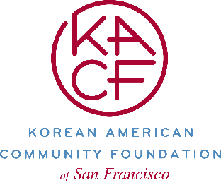
Electronic Transfer Authorization Form

Please transfer the listed securities from my account to Korean American Community Foundation of San Francisco’s account with FIDELITY using the following information:

FIDELITY BUSINESS
Account Name: Korean American Community Foundation of San Francisco (KACF SF)
Tax ID Number: 46-5212292
Account Number: Z48-711159
Broker DTC Number: 0226

Brokerage Information
Broker’s Name:
Brokerage:

Personal Information
Account Number:
Name/Title:
Address:

Securities Information
Name of Security Number of Shares/Bond Face Value

Signed (Donor) Date:

Signed (Donor, Joint-Owner) Date:

